The rule cache is also referred to as database cache or system cache, contains recently found rules that are used to improve the performance of the engine, especially during rule resolution searches. The system adds to the cache any rule that is read three or more times, however, for some rule types, a higher limit applies.

Instances of most concrete classes other than those derived from the Rule- base class are not cached in the rule cache.

In a clustered system, a rule recently updated by a user on one node can also be present (and stale) in the rule cache of another node. During system pulse processing, the Pega-RULES agent on each node clears such stale rules from the rule cache.

Assessing rule cache performance

For an overview of rule cache performance on node since startup

1. Start the system management application
2. Select advanced > Rule Cache Management

Determining rule cache rule count and size

Use the System Management Application (SMA) to view the current rule count and size in bytes of the rule cache.

1.  From Designer Studio, start the System Management Application by clicking **Designer Studio**> System > Operations > System Management. You might be prompted for a username and password.

2.  Select a node.

3.  Click **Memory Management**.

4.  In the **Caches** group, locate the row corresponding to your application's caching type.

From 8.1 you have to go for the admin studio and add pxAdminStudio to see the SMA and pega has provided API for the system management.

Sample screenshots

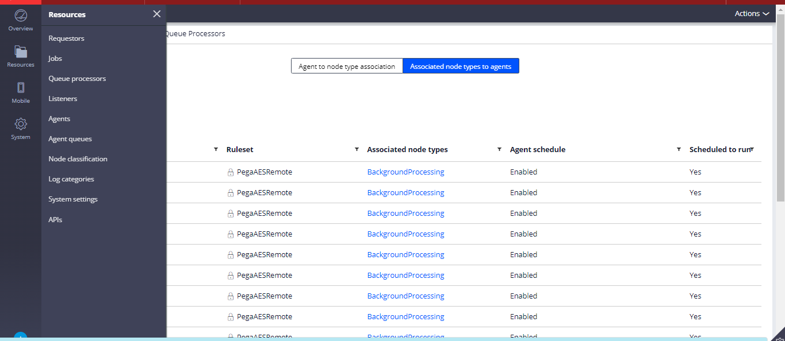

Disabling the rule cache

As a diagnostic aid to be used in specific situations, you can use the System Management Application (SMA) to temporarily disable the rule cache.

This event is recorded in the Alert log as the PEGA0022 alert. The corresponding alert when you re-enable the rule cache is the PEGA0023 alert.

For more information, see PDN articles *Understanding the PEGA0022 alert* and *Understanding the PEGA0023 alert.*

**Caution:**Use the System Management Application only when necessary and for short intervals because system performance is impaired when the rule cache is disabled.

Static Content Cache

The Pega 7 Platform stores static content for these rule types:

* Binary file rules (*Rule-File-Binary* rule type, for images such as JPG files)
* Text file rules (*Rule-File-Text* rule type, for JavaScript and Cascading Style Sheet files)
* Form file rules, for rule forms (*Rule-File-Form* rule type)
* eForm file rules (*Rule-File-eForm* rule type, for PDF forms)

The location of the StaticContent directory is determined by a temporary files path setting in the prconfig.xml file. Each directory below the StaticContent directory contains extracted static content. Additionally, the directory name encodes the exact ruleset list that the content belongs to. To minimize storage, the Pega 7 Platform creates directory names with a hash code derived from an entire ruleset list.

For example, the file system can contain many different files named CompanyLogo.jpg. The CompanyLogo.jpg file that is displayed in a browser session depends on that user's ruleset list.

**Note:**Use the System Management application to delete all the static content extracted on the current node.